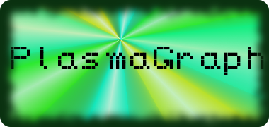

Software Project Management Plan

for

PlasmaGraph

Version 2-2014-05-15

|  |  |  |
| --- | --- | --- |
| Daniel E. Quintini (# 73749) |  | Gerardo A. Navas (# 69615) |
| Computer Science Undergraduate Program |  | Computer Science Undergraduate Program |

Polytechnic University of Puerto Rico

May 15, 2014

Advisor: Prof. Luis A. Ortiz Client: Prof. Angel Gonzales-Lizardo

Revision History

|  |  |  |
| --- | --- | --- |
| **Version** | **Date** | **Reason For Changes** |
| 1-2013-11-11 | Friday, November 11, 2013 | First version of document. |
| 1-2014-04-27 | Sunday, April 27, 2014 | Changes to title page, page numbers, addition of a preface, page numbers on the Table of Contents, addition of various tables and lists for terms and the like, general sentence reorganization all around the document, and additional information provided for group member roles. |
| 2-2014-05-15 | Thursday, May 15, 2014 | Correction of errors Advisor found. Included missing references. Added diagrams to Process Model to describe phases. Added information regarding Software Documentation aside from Javadocs. Added information regarding resources used per Work Package, and cost of resourced. Included tentative table for Budget and figures for gantt chart schedule. |
| 3-2014-05-20 | Tuesday, May 20, 2014 | Correction of various typographical errors around the document. Reduced size of various figures to be smaller than a single page. Modified Section 3.2 to discuss project management more closely. Added project schedule to Section 5.5 and end dates to Work Packages in Section 5.1. Changed Appendix A to “Advisor Meeting Notes” and added all meeting notes as of 5/20/2014. |

Preface

This document, the Software Project Management Plan (SPMP), exists to detail the organization of the Plasma Visualization Group's PlasmaGraph project. It is specifically-designed to communicate how the project will begin, progress, and what are its end goals, but not what the project entails. Those reading this document should be interested in understanding facets of the management of this project.

Table of Contents

1. Introduction 1

1.1. Project Overview 1

1.2. Project Deliverables 1

1.3. Evolution of the SPMP 2

1.4. Reference Materials 3

1.5. Definitions and Acronyms 5

2. Project Organization 7

2.1. Process Model 7

2.2. Organizational Structure 9

2.3. Organizational Boundaries and Interfaces 10

2.4. Project Responsibilities 11

3. Managerial Process 12

3.1. Management Objectives and Priorities 12

3.2. Assumptions, Dependencies, and Constraints 13

3.3. Risk Management 14

3.4. Monitoring and Controlling Mechanisms 16

3.5. Staffing Plan 21

4. Technical Process 23

4.1. Methods, Tools, and Techniques 23

4.2. Software Documentation 24

4.3. Project Support Functions 27

5. Work Packages, Schedule, and Budget 28

5.1. Work Packages 28

5.2. Dependencies 36

5.3. Resource Requirements 38

5.4. Budget and Resource Allocation 40

5.5. Schedule 43

Appendix 46

Appendix A: Advisor Meeting Notes 46

List of Figures

Figure Page

Figure 1: Process Model Phase Diagrams 7

Figure 2: Team Organizational Structure 9

Figure 3: Project Organizational Boundaries and Communication Channels 10

Figure 4: Main Directory Organization 18

Figure 5: PlasmaGraph Directory Organization 19

Figure 6: Specs Directory Organization 20

Figure 7: Work Package Dependency Diagram 36

Figure 8: "PlasmaGraph Program" Work Package Dependency Diagram 37

Figure 9: Project Phase Schedule - Phase A 43

Figure 10: Project Phase Schedule - Phase B 43

Figure 11: Project Phase Schedule - Phase C 44

Figure 12: Project Phase Schedule - Phase D 44

Figure 13: Project Phase Schedule - Phase E 45

List of Tables

Table Page

Table 1: Document Definitions 5

Table 2: Document Acronyms 6

Table 3: Software Used in Project, Ordered by Purpose 23

Table 4: Intermediate Document and Image Formats 24

Table 5: Work Package Labels and Phases 28

Table 6: Resources Used for Project Deliverables 39

Table 7: Project Resources and Budget 40

# 1. Introduction

## 1.1. Project Overview

This document covers the plan for the creation of the PlasmaGraph graphing tool for the Polytechnic University of Puerto Rico's (PUPR's) Plasma Laboratory. PlasmaGraph is a graphing tool, enabling easier graphing capabilities compared to those of MathWorks' Matlab [1] product, the product currently in use by the Plasma Lab. A number of basic capabilities will be included with this initial product; they will be listed and described in the Software Requirement Specification (SRS) document.

Progress in this project will be measured by the completion of particular milestones, which will be delineated in Part 5 of this document, “Work Packages, Schedule, and Budget”. Completion will be measured by how the product completes the testing detailed in the Software Test Documentation (STD), also included with this document. Once completed, the team will present the finalized product and provide various components of the project to the client, including the program code and its documentation. This project will form a part of the continuity of physical and digital systems currently in use by the PUPR Plasma Laboratory to pull data from their experiments and understand them.

## 1.2. Project Deliverables

The client, Professor Angel Gonzales-Lizardo of the Polytechnic University of Puerto Rico's Plasma Laboratory, must receive the following items at his office in the PUPR Plasma Lab by Friday, May 30, 2014 at 12:00 PM Atlantic Standard Time (UTC/GMT – 04:00):

A. One (1) digital copy of the PlasmaGraph Product (Section 5.1, Work Package B) and Program Documentation (Section 5.1, Work Package C), in a CD-ROM.

B. One (1) physical (paper, softcover) copy of the PlasmaGraph User Manual and Installation Guide.

C. One (1) physical copy of the following Project Documentation documents (Section 5.1, Work Package A):

1. The Software Project Management Plan (SPMP)

2. The Software Requirements Specification (SRS)

3. The Software Design Description (SDD)

4. The Software Test Document (STD) and Test Result Report(s).

D. One (1) digital copy of all Project Presentations (Section 5.1, Work Package D) performed throughout the duration of the project.

E. One (1) physical poster summarizing the project.

## 1.3. Evolution of the SPMP

The SPMP document will be created and modified as follows:

* The document will be divided in parts based on each of its sections. For example, Section 1.3 of this document will have its individual file in the project repository (Section 3.4, Sub-Section A) containing the most recent version of the section.
* Each section file will be named only by its section’s name.
* Once changes are finalized to each section file, the individual section files’ contents will be copied to the correct section in the SPMP template document file (SPMP-template.docx).
* The SPMP document can be saved in any of the Project Documentation formats listed in Section 4.1, Sub-Section A.
* The SPMP document’s name will have a version number following the rules stipulated in Section 4.2.
* Once the document is approved by an advisor (Professor Luis A. Ortiz Ortiz), the SPMP can be saved in any of the Project Documentation formats listed in Section 4.1, Sub-Section B.

All versions of the SPMP will be located in the project's GitHub [2] version control system, (https://github.com/TakoArishi/PlasmaGraph) under the directory “specs/SPMP/”. Document parts will be stored in folders labelled from Sections 1 to Section 5. Completed SPMP documents will be stored in the “specs/SPMP/” directory.

## 1.4. Reference Materials

|  |  |
| --- | --- |
| [1] | The MathWorks, Inc., "MATLAB - The Language of Technical Computing," [Online]. Available: http://www.mathworks.com/products/matlab/?s_tid=hp_fp_ml. [Accessed 12 May 2014]. |
| [2] | GitHub, Inc., "About - GitHub," [Online]. Available: https://github.com/about. [Accessed 12 May 2014]. |
| [3] | Object Refinery Limited, "JFreeChart," Object Refinery Limited, 25 November 2013. [Online]. Available: http://www.jfree.org/jfreechart/. [Accessed 13 May 2014]. |
| [4] | Oracle Corporation, "What is Java and why do I need it?," 25 March 2014. [Online]. Available: http://www.java.com/en/download/faq/whatis_java.xml. [Accessed 13 May 2014]. |
| [5] | Merriam-Webster, "Dictionary and Thesaurus - Merriam-Webster Online," [Online]. Available: http://www.merriam-webster.com/. [Accessed 12 May 2014]. |
| [6] | B. Goines, S. Chacon and M. McCullough, "Git - About Version Control," [Online]. Available: http://git-scm.com/book/en/Getting-Started-About-Version-Control. [Accessed 13 May 2014]. |
| [7] | PC.net, "Definition of IDE," [Online]. Available: http://pc.net/glossary/definition/ide. [Accessed 13 May 2014]. |
| [8] | Polytechnic University of Puerto Rico, "Polytechnic University of Puerto Rico - Main Page," [Online]. Available: http://www.pupr.edu/. [Accessed 13 May 2014]. |
| [9] | Institute of Electrical and Electronics Engineers, "IEEE Standard for Software Project Management Plans," 22 December 1998. [Online]. Available: http://ieeexplore.ieee.org/stamp/stamp.jsp?tp=&arnumber=741937&isnumber=16012. [Accessed 8 May 2014]. |
| [10] | Institute of Electrical and Electronics Engineers, "IEEE Recommended Practice for Software Requirements Specifications," 22 December 1998. [Online]. Available: http://ieeexplore.ieee.org/stamp/stamp.jsp?tp=&arnumber=720574&isnumber=15571. [Accessed 13 May 2014]. |
| [11] | Institute of Electrical and Electronics Engineers, "IEEE Recommended Practice for Software Design Descriptions," 22 December 1998. [Online]. Available: http://ieeexplore.ieee.org/stamp/stamp.jsp?tp=&arnumber=741934&isnumber=16019. [Accessed 13 May 2014]. |
| [12] | Institute of Electrical and Electronics Engineers, "IEEE Standard for Software Test Documentation," 22 December 1998. [Online]. Available: http://ieeexplore.ieee.org/stamp/stamp.jsp?tp=&arnumber=741968&isnumber=16010. [Accessed 13 May 2014]. |
| [13] | The Mathworks, Inc., "MATLAB® MAT-File Format," September 2013. [Online]. Available: http://www.mathworks.com/help/pdf_doc/matlab/matfile_format.pdf. [Accessed 26 January 2014]. |
| [14] | Git SCM, "Git - GUI Clients," [Online]. Available: http://git-scm.com/downloads/guis. [Accessed 14 May 2014]. |
| [15] | "How to Write Doc Comments for the Javadoc Tool," 16 November 2012. [Online]. Available: http://www.oracle.com/technetwork/java/javase/documentation/index-137868.html. [Accessed 13 May 2014]. |
| [16] | R. C. Martin, "UML Java Programmers," 10 December 2008. [Online]. Available: http://www.csd.uoc.gr/~hy252/references/UML_for_Java_Programmers-Book.pdf. [Accessed 24 04 2014]. |
| [17] | t. t. w. cbwatcham, "JMatIO - Matlab's MAT-file I/O in JAVA," 04 December 2012. [Online]. Available: http://sourceforge.net/projects/jmatio/. [Accessed 14 May 2014]. |
| [18] | Apache Software Foundation, "Math - Commons Math: The Apache Commons Mathematics Library," 02 November 2013. [Online]. Available: http://commons.apache.org/proper/commons-math/index.html. [Accessed 12 February 2014]. |
| [19] | Oracle Corporation, "Java SE Application Design With MVC," March 2007. [Online]. Available: http://www.oracle.com/technetwork/articles/javase/index-142890.html. [Accessed 15 May 2014]. |
| [20] | JUnit Team, "JUnit," 24 January 2014. [Online]. Available: http://junit.org/. [Accessed 21 May 2014]. |

## 1.5. Definitions and Acronyms

Unless otherwise specified, all definitions and acronyms are specific to this project’s scope.

Table : Document Definitions

| Term | Definition |
| --- | --- |
| PlasmaGraph / Product | A Matlab-file error-checking graphing program made for the PUPR Plasma Laboratory. |
| Client | Professor Angel Gonzales-Lizardo; the person requesting the project. |
| Advisor | University-designated overseer of the project's progress. |
| JFreeChart [3] | A set of tools written in the “Java” programming language that create graphical representations of data provided to it. |
| Matlab [1] | Data-manipulation and graphing IDE made by The Mathworks, Inc. |
| Java [4] | Object-oriented, interpreted programming language known for its portability between multiple operating systems and general-purpose capabilities. |
| Operating System [5] | Software that controls the operation of a computer and directs the processing of programs (as by assigning storage space in memory and controlling input and output functions). |
| Project Team / Team | The creators and maintainers of the project and all of its end products. Composed of Gerardo A. Navas Morales and Daniel E. Quintini Greco. |
| Version Control System [6] | Manages how multiple users can access and change the same files without losing data. Also known as a Revision Control System or Source Control System |
| Integrated Development Environment [7] | Software development program that keeps track of all files related to a project and provides a central interface for writing source code, linking files together, and debugging the software. |
| Vetting work packages | The process of reviewing a work package for semantical errors, documentation requirements (if a document), or programming errors (if a program). |
| Program Documentation | All Javadoc files and the User Manual. |
| Project Documentation | The SRS, SDD, STD, and SPMP documents. |
| Polytechnic University  of Puerto Rico [8] | University where the Plasma Laboratory is located, as well as where the group's members study. |
| Software Project Management Plan / SPMP [9] | This document; One of the four IEEE project documents being created as part of this project. |
| Software Requirements Specification / SRS [10] | One of the four IEEE project documents being created as part of this project. |
| Software Design Descriptions / SDD [11] | One of the four IEEE project documents being created as part of this project. |
| Software Test Documentation / STD [12] | One of the four IEEE project documents being created as part of this project. |
| Graphical User Interface / GUI [5] | A computer program designed to allow a computer user to interact easily with the computer typically by making choices from menus or groups of icons. |
| Development | Creation of product code. |
| PNG / .png / JPG / JPEG /  .jpg / .jpeg | Types of computer files that hold image data. |
| MAT / .mat | Matlab data file format. |
| Contributor | A GitHub user status; allows the user to make changes to the project. |
| Incomplete document | A document with one or more sections labelled [TBD]. |
| Complete document | A document with no sections labelled [TBD]. |
| Document verification | The process an Advisor performs on a document to check for errors. |
| GitHub [2] | File repository system that uses the Git Version Control System. [2] |
| JUnit [13] | Testing framework used for the automation of program tests. |

Table : Document Acronyms

|  |  |
| --- | --- |
| Term | Acronym |
| PUPR | Polytechnic University of Puerto Rico. |
| SPMP | Software Project Management Plan. |
| SRS | Software Requirement Specification. |
| SDD | Software Design Descriptions. |
| STD | Software Test Documentation. |
| GUI | Graphical User Interface. |
| VCS | Version Control System |
| IDE | Integrated Development Environment. |

# 2. Project Organization

## 2.1. Process Model

The PlasmaGraph project will be divided into five phases, each of which must be completed in order. The following diagram details the project team’s required activities in order from start to finish.

Figure : Process Model Phase Diagrams

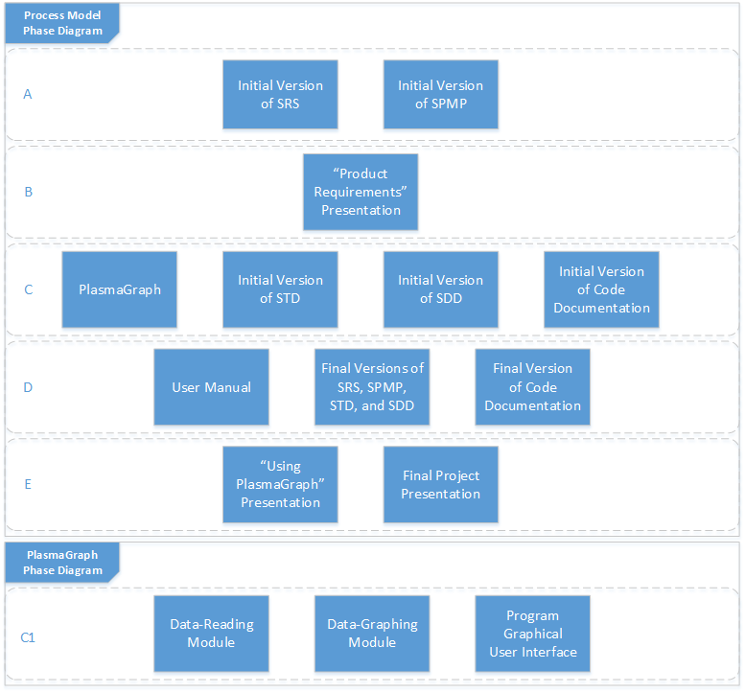

As can be seen in Figure 1, the project will be divided into five phases, each labelled in alphabetical order. The phases are:

1. Creation of the initial SRS and SPMP documents.
2. Presentation of the Project Requirements.
3. Creation of the PlasmaGraph product, initial versions of the STD and SDD documents, and the initial version of the product’s code documentation.
4. Creation of the User Manual and final versions of the Code Documentation and SRS, SDD, STD, and SPMP documents.
5. Presentation of the Product (PlasmaGraph).

Furthermore, the creation of the PlasmaGraph product, located in phase C, is separated into the following simultaneous tasks:

C1. Creation of the Data-Reading Module

C2. Creation of the Data-Graphing Module

C3. Creation of the Program’s Graphical User Interface (GUI)

A thorough explanation of what each phase of this project entails is found in the section entitled “Work Packages”, section 5.1. Furthermore, the time required to complete these phases will be explained in section 5.5 (“Schedule”).

## 2.2. Organizational Structure

This project will be completed by the following people (their positions are included in parentheses):

* Gerardo A. Navas Morales (Project Manager)
* Daniel E. Quintini Greco (Design Manager)

As shown in the following diagram, the positions of these two project members are equivalent with regards to project management hierarchy:

Figure : Team Organizational Structure

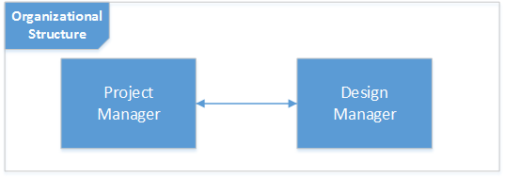

## 2.3. Organizational Boundaries and Interfaces

The project team will handle the following items related to the project:

Figure : Project Organizational Boundaries and Communication Channels

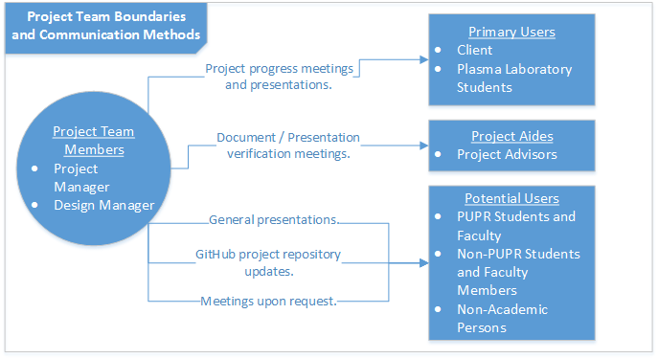

The project team will handle communication between itself and the three external group types as follows:

1. Primary Users: Both the client and the students that work in the Plasma Laboratory will be provided information regarding the PlasmaGraph product via progress meetings and presentations as needed.
2. Project Aides: The team will meet with any and all project advisors whenever a document or presentation is ready to be verified for errors.
3. Potential Users: Meetings with people that are not currently involved with the project will be met with upon their request. Any parties interested in the results of this project will be updated with the status of the project via the GitHub project repository or any presentations made to the general public.

## 2.4. Project Responsibilities

As described in section 2.2 of this document, this project's team is composed of two (2) members. The duties that these two members must perform are as follows:

* Shared Responsibilities
  + Research, design, develop, and maintain product.
  + Develop and maintain product documentation.
  + Manage meetings with the client and Plasma Laboratory students.
  + Develop and present product according to the Work Package Diagrams in Section 5.1.
  + Provide all materials to the client upon completion of the project.
* Individual Responsibilities
  + Project Manager
    - Develop and Maintain the SPMP and SDD documents.
    - Manage weekly project updates.
    - Maintain project’s GitHub repository
  + Design Manager
    - Develop and maintain the SRS and STD documents.
    - Schedule and oversee Primary User (See Section 2.3) testing.
    - Serve as intermediary between Project Manager and Primary Users (See Section 2.3).

# 3. Managerial Process

## 3.1. Management Objectives and Priorities

This section will cover what the project goals are and how the team will reach them.

1. Purpose

This project team was organized in order to create a product, named “PlasmaGraph”, for the client. This product will be able to take a Matlab Level-5-formatted data file [13] and the graph details (settings), and will produce a graph containing the data according to the settings selected by the user. The client has requested this tool to substitute the use of Matlab, currently being used to produce all graphs in the Plasma Laboratory.

1. Priority

The project is divided into two general sections: the program (the working product, including its code documentation) and its documentation (its specifications and the User Manual and Installation Guide that will be provided alongside the product). The priorities for each are as follows:

* 1. Documentation Priority: The SPMP and SRS documentation for the project is required before beginning the development of the product.
  2. Product Priority: The team will not begin development on the product until initial drafts of the SRS and SPMP Work Packages (See Section 5.1) have been completed.

1. Communication and Meetings

Team members can communicate with each other via e-mail, telephone conversations, text messages, instant messaging, and in meetings. Group members will exchange telephone contact information during the first official meeting of the project group, and may provide additional contact vectors as needed.

Official meetings will be decided upon at least one day in advance, and must last for at least one hour. The ideal period of time for meetings will be on Tuesdays or Wednesdays from 4:00 PM to 6:30 PM. Unofficial meetings follow the same pattern, but need not be constrained to the minimum time requirement that official meetings are.

Meetings with the Advisor and the Client will all be official. Meetings with the Advisor will be held weekly and be logged via meeting notes (specs/Notas de Reuniones/) that will be signed by all team members, describing what has been done during the week and what should be done for the following week. Meetings with the client will not be recorded in the same way; instead, the project team will meet with him with a number of questions and will end the meeting when questions have been answered and when all the requests by the client have been answered satisfactorily. All meeting notes will be appended in Appendix A.

1. Schedule

Refer to Section 5.5 of this document for how the project's schedule will be organized.

1. Budget / Resources

Refer to Sections 5.3 and 5.4 for how the project's budget and resources will be used and allocated.

## 3.2. Assumptions, Dependencies, and Constraints

The Plasma Visualization Group operates under a number of assumptions and constraints in order to create the product:

* Assumptions
  + Test data will be provided by the PUPR Plasma Laboratory students to the Design Manager in order to successfully test PlasmaGraph.
  + At least one (1) PUPR Plasma Laboratory student will be required to perform the tests detailed in the STD for successful completion of the project.
* Constraints
  + The project’s duration will not exceed 10 months.
  + The project will be completed with only two (2) members
* Dependencies
  + The PVG team must work with the Client and the PUPR Plasma Laboratory students to set a standard format for PlasmaGraph data files.

## 3.3. Risk Management

Problematic situations may occur throughout the duration of this project. This list will detail what are the measures that will be taken to minimize risk:

A. Project Members

1. Constant communication is mandatory, whether through phone, e-mail, or meetings.
2. Whenever a meeting is scheduled, all project members must participate in that meeting. Persons that do not participate in at least half of the group meetings without valid reasons will be removed from the project group.
3. Work will be divided evenly. In case of a member believing the tasks given to them are uneven or unsuited, the team member can bring up the complaint to the Project Manager via any communication medium. The Project Manager must then decide to either not change the task or assign a different task.
4. If a project member does not participate in a meeting, the member must be contacted via any communication medium to update them of the meeting’s results, and the member must send a confirmation message that they received the information.
5. All project members must perform roughly equal work to be credited properly. For the purposes of this point, "roughly equal work" refers to a 50/50% split, with a variance of 15%. Any members that do not comply with this rule will be removed from the team.
6. If the document-hosting service or the code-hosting service is terminated by either the Project Manager or a third party, the Project Manager's version of these documents or code will be used as the basis of all future development. These files will then be uploaded onto another service with similar privacy protection as agreed upon by the Project Manager. Once this is done, this change must be communicated to all project members via any medium, and must explain the change and how to access the new versions.

B. Client

1. Meetings with the Client will occur when a milestone has been reached, but communication regarding the group's current progress should occur periodically so as to provide some amount of feedback to the Client.
2. Features requested after the first meeting are not guaranteed to appear in the first version of the finished product. Instead, they will be accommodated as possible into the schedule.
3. If the Client wishes to drop the project, the project will continue to its conclusion, relying on the Advisor as backup client.

C. Advisor

1. Meetings with the Advisor will occur weekly on Thursdays at 4:00 PM to 4:30 PM. Project group members will come with a log of their weekly accomplishments and the following week's proposed tasks.
2. If a certain part of the project requires multiple rounds of feedback from the advisor, additional meetings between the project member(s) and the advisor should be scheduled throughout the week.
3. If the Advisor finds himself unable to continue work on the project or unwilling to provide adequate feedback on the components for multiple months for whatever reason, the project members will submit a request for a new advisor willing to provide assistance to the project.

## 3.4. Monitoring and Controlling Mechanisms

This section details how this product will be distributed and managed during its development in this section.

1. Project Repository

The PlasmaGraph project's files will be distributed and managed via the project's GitHub page. GitHub is a version control system designed to manage multiple versions of files, allowing for easy access while providing excellent error-correction mechanisms. The primary version of the project is called the “master”, whereas all other versions are called “branches”.

The GitHub repository may be manipulated either via the official website [2] or via any tool [14] that is able to interact with repositories via the Git system.

The following is a list of rules that all member must follow to work on the project:

* All team members must request Contributor status to the Project Manager in order to work on the project.
* All members must create a new branch in order to begin work on any section of the project.
* Work must be performed on the member's own branch, unless requested to by the branch owner or the Project Manager (Refer to C for details regarding the logging of changes into the GitHub repository).
* When work is finished on a branch, a pull request must be initiated by the branch owner. The Project Manager will then evaluate the work. If the branch has completed its purpose, the Project Manager will merge the new branch into the master branch.

The project's GitHub web page is located at: https://github.com/TakoArishi/PlasmaGraph.

1. Repository Management

Each project member will maintain their own personal version of the project's contents, known as a "branch". This isolates their changes and allows them to manage their work until their work is ready to be added to the main branch's ("master") contents. This section will discuss how the project members will perform these changes, view their changes, and include their work into the project's "master" branch.

1. Documenting Changes

Project members must follow the following rules while logging changes to the GitHub repository:

* First, members must add all files to be logged via the Git command “Add”.
* Second, the Git command “Commit” must be used to document the changes via a descriptive message of what changes the update contains.
* Finally, the Git command “Push” will synchronize the changes to the member's branch in the GitHub repository.

1. Reviewing Changes

Changes can be reviewed via the GitHub project's "Commits" page. The commits of branches that aren't the main one can be accessed by using the "Branches" viewing option and selecting the desired branch.

1. Moving Changes to the Master Branch

When a milestone has been reached in a branch (such as when a specification document like the SRS / SDD / STD / SPMP is completed). The milestone should be moved to the main branch via the Pull Request function. The process is as follows:

* The team member must create a Pull Request between the “master” branch and their branch. This Pull Request must include a comment describing the work done to reach the milestone.
* The Project Manager will approve or deny the Pull Request based on the work done in the branch.

This process allows other project members to routinely take advantage of new work related to the project without sacrificing much of the main branch's quality.

1. Repository Organization

The project's GitHub repository will be structured in the following format:

Figure : Main Directory Organization

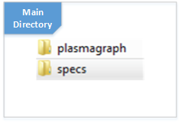

The main directory will contain two different folders:

* The “plasmagraph” folder contains the contents of the Work Packages labelled “PlasmaGraph” and “Code Documentation” (see Section 5.1).
* The “specs” folder will hold the contents of any work package that isn't held in the “plasmagraph” folder (see Section 5.1).

The “plasmagraph” directory will contain the following sub-directories:

Figure : PlasmaGraph Directory Organization

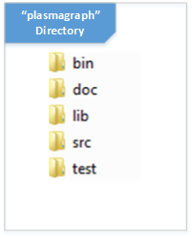

* The "bin" directory will hold the compiled versions of the product.
* The "doc" directory will hold the JavaDocs created as a result of the code documentation (See Work Package B1 in section 5.1 of this document for more details) .
* The "lib" directory will hold additional libraries used by the project via the JAR files that are linked via the Eclipse "External Libraries".
* The "src" directory will hold the Eclipse workspace; all relevant files that directly form part of the PlasmaGraph product will be saved in the repository.
* Finally, the "test" directory will hold the environment for testing the product, including sample test data and test template data.

Finally, the “specs” directory will contain these sub-directories:

Figure : Specs Directory Organization

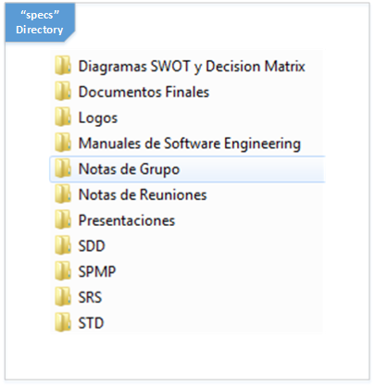

* The “Diagramas SWOT y Decision Matrix” sub-directory will contain all diagrams and materials used in the programming language, tools, and decisions made at the start of the project.
* The “Documentos Finales” sub-directory will contain the release-ready versions of the SRS, SDD, STD, and SPMP documents. Documents in this sub-directory will be actualized with the currently-released version.
* The “Logos” sub-directory will contain all logos related to the PlasmaGraph project and the Plasma Visualization Group team.
* The “Manuales de Ayuda” sub-directory will contain all supplementary documents used for the creation and maintenance of the project and all its work packages.
* The “Notas de Grupo” sub-directory will contain all notes that are important for the functioning of the team.
* The “Notas de Reuniones” sub-directory will contain all meeting notes between the team and the client or any other external party.
* The “Presentaciones” sub-directory will contain all the project's PowerPoint presentations and their respective materials.
* The “SDD”, “SPMP”, “SRS”, and “STD” sub-directories will contain their respective documents, along with all the images, diagrams, and other document fragments.

1. Problem Resolution

Solutions to possible repository problems that may arise will be considered on a per-situation basis. The Project Manager must discuss the options available with the Design Manager before resolving the situation.

## 3.5. Staffing Plan

A minimum of two persons will be required to complete this product, both of which should have various qualifications. Training will be available for potential members with lack of experience with certain programming tools. These persons, as well as the requirements for each, are as follows:

1. Project Manager

The Project Manager is the director of the team, orchestrating the meetings between the client and team members, maintaining the SPMP and SDD, and managing the GitHub project repository used by the group.

This person must have previous experience working with SRS, SDD, STD, and SPMP documents, and should have extensive university-level class experience in programming and program design. The person should also have some experience with team management, and should also have extensive experience with the programming language being used in the project.

1. Design Manager

The Design Manager is the mastermind of the SRS and STD. The person will detail what functions the product will perform and how will these functions be tested to ensure their compliance to the client's request.

The person must have previous experience working with SRS, SDD, STD, and SPMP documents, and should have extensive university-level class experience in programming and program design. It is recommended for them to have some experience with the programming language being used in the project.

Any substitution of current personnel must be done with the following:

1. A new qualified person ready for immediate assignment.
2. The approval by all Advisors working with the project team’s members.

Training will be provided by the Project Manager or Design Manager to the new member(s) of the project group as needed.

# 4. Technical Process

## 4.1. Methods, Tools, and Techniques

The creation of the PlasmaGraph product will be done using the following:

1. Programming Language

Java Version 7 will be used to create the product.

1. Project Development Software

The following table details all the software used in the project:

Table : Software Used in Project, Ordered by Purpose

|  |  |
| --- | --- |
| Software Purpose | Software Used |
| Diagramming Software | OpenOffice Draw, Microsoft Visio 2013, Dia |
| Document Software | Microsoft Word 2013, OpenOffice Writer, OpenOffice Calc, Sublime Text 2, Sublime Text 3 |
| Scheduling Software | Microsoft Project 2013 |
| Presentation Software | Microsoft PowerPoint, OpenOffice Impress |
| Programming Software / IDEs | Eclipse, Netbeans IDE |
| VCS | Git, GitHub |
| Image-Manipulation Software | GIMP, Paint.NET, MSPaint |
| Research Software | Mozilla Firefox, Google Chrome |

1. Operating System

The Operating System (OS) used to create PlasmaGraph must be any version of Windows 7.

1. Intermediary Document and Image Formats

The following table details the possible formats for any components of the “Project Documentation” and “Code Documentation” Work Packages. (See Section 5.1)

Table : Intermediate Document and Image Formats

|  |  |
| --- | --- |
| Document | Extension |
| Diagramming Document Format(s) | .dia |
| Text Document Format(s) | .txt, .doc, .docx, .md |
| Code Document Format(s) | .java |
| Image Format(s) | .png, .jpg, .jpeg |
| Presentation Format(s) | .pptx, .ppt, .odt |

1. Testing Techniques

The testing techniques used to verify the functionality of PlasmaGraph are detailed in PlasmaGraph’s STD. Automated testing of basic program code functionality will be handled via the JUnit testing framework, whereas manual testing will be performed to verify proper GUI functionality.

Furthermore, the following is required in order to run the final PlasmaGraph product:

1. Java Version

Java Version 7 or newer is required to run PlasmaGraph.

1. Operating System

The Operating System (OS) used to run PlasmaGraph must be able to run Java Version 7 or newer.

## 4.2. Software Documentation

Software documentation explains not only how the product is designed and made, but what the product's code does in order to fulfill the client's requirements.

* A combination of Document, Diagramming, Scheduling, and Image-Manipulation Software will be used to create the project documentation.
  + The SRS, SDD, STD, and SPMP documents must be made following IEEE format specifications [10] [11] [12] [9].
  + Versioning for all of these documents will be contained in the name of the document’s file and will use the following format (each point being separated by a hyphen):
    - The name of the document.
    - A number from 0-3 indicating readiness of the document.
      * Zero (0) refers to an incomplete document.
      * One (1) refers to a complete document that has not been verified by an Advisor.
      * Two (2) refers to a complete document that has been verified but rejected by an Advisor due to errors.
      * Three (3) refers to a complete document that has been verified and approved by an Advisor.
    - The date the document was submitted to the Advisor for verification. The date will be formatted in the following order (each part is separated by a hyphen).
      * Year
      * Month
      * Day
* The Java-provided tool “javadoc” will be used to create the code documentation. To do so, however, the following rules must be adhered to:
  + Each Java Package, Class, and Method must be documented via JavaDoc comment format. [15]
  + All Java Packages must contain the following JavaDoc comment components in their “package-info.java” file:
    - Package content summary.
    - One “@author” tag. The default author for this project is “Plasma Visualization Group”.
  + All Java Classes must contain the following JavaDoc comment components:
    - Class summary.
    - One “@author” tag. The default author for this project is “Plasma Visualization Group”.
  + All public Java Methods must contain the following JavaDoc comment components:
    - Method summary.
    - One “@param” tag per method parameter.
    - One “@return” tag, unless the method is a void method.
* The PlasmaGraph User Manual and Installation Guide will be formatted with the use of Document and Image-Manipulation Software as follows:
  + The first section of the manual will detail the installation of the product on the Operating System used on the computers in the Plasma Laboratory, Windows 7.
  + The second section of the manual will detail the usage of the product in this order:
    - Creation of a simple graph.
    - Graph modifications.
    - Saving and loading modifications (Templates).
    - Saving graphs as images.
    - Interpolation of graph data.
    - Searching for Outliers.
    - Grouping data by a third column.
  + Versions for the User Manual and Installation Guide will be managed in the same manner as the project documentation.

## 4.3. Project Support Functions

This project requires various minor functions in order to operate certain sections and guarantee quality.

A. Software Quality Assurance

The quality of the final product will be confirmed in three ways:

1. Mutual Oversight: Both the Project and Design Managers must communicate with each other, explaining how their contributions help to reach the final goal. This applies to all phases of the project.
2. Software Documentation: All programmers (Project Manager and Design Manager) must document their code. This allows others to understand the product's internals better and find programming errors.
3. Testing: Please refer to the STD for information regarding how the product will be tested.

B. Configuration Management

1. Initial IDE Configuration: Initial configuration of the development environment will be explained via the “README.md” file located in the root of the GitHub repository.
2. Final Product Configuration: Configuration details of the final product's environment will be detailed in the supplementary User Manual (See Section 5.1).

# 5. Work Packages, Schedule, and Budget

## 5.1. Work Packages

The project team must implement all the requirements stipulated in section 2.2 of the SRS. To do so, the team must complete the following components, known as Work Packages:

Table : Work Package Labels and Phases

|  |  |  |
| --- | --- | --- |
| Work Package | Package Label | Project Phase(s) |
| Software Requirement Specification (SRS) | A1 | A, D |
| Software Design Description (SDD) | A2 | C, D |
| Software Test Documentation (STD) and Test Result Report(s) | A3 | C, D |
| Software Project Management Plan (SPMP) | A4 | A, D |
| Data Reading Module | B1 | C |
| Data Graphing Module | B2 | C |
| Program Graphical User Interface | B3 | C |
| Code Documentation (Javadocs) | C1 | C |
| User Manual and Installation Guide | C2 | C |
| “Product Requirements” Presentation | D1 | B |
| “Using PlasmaGraph” Presentation | D2 | E |
| Final Project Presentation and Project Poster | D3 | E |

The following explanations will describe the purpose of each work package mentioned above:

A. Project Documentation

A1. Software Requirement Specification (SRS) [10]

* Description: This document describes the product from an external viewpoint. It specifies the key features of the product as requested by the client, as well as what the product needs in order to perform its functions.
* Product: Project Deliverable C2 (See Section 1.2)
* Resources Used: (See Section 4.1 for resources used throughout the project.)
  + Hardware: All hardware.
  + Software: Document, Diagramming, and Image-Manipulation Software.
  + Personnel: Design Manager.
  + Other: None.
* Start Date: 8/14/2013
* End Date: 5/14/2014

A2. Software Design Description (SDD) [11]

* Description: This document details the product's internal structure and how it performs its most crucial processes in a step-by-step manner via the use of various types of UML diagrams [16].
* Product: Project Deliverable C3 (See Section 1.2)
* Resources Used: (See Section 4.1 for resources used throughout the project.)
  + Hardware: All hardware.
  + Software: Document, Diagramming, and Image-Manipulation Software.
  + Personnel: Project Manager and Design Manager.
  + Other: None.
* Start Date: 11/21/2013
* End Date: 5/29/2014

A3. Software Test Document (STD) and Test Result Report(s) [12]

* Description: This document details the different tests that prove the product adheres to the requirements specified by the client and written in the SRS. This document also contains a collection of results for each test performed according to its specifications.
* Product: Project Deliverable C4 (See Section 1.2)
* Resources Used: (See Section 4.1 for resources used throughout the project.)
  + Hardware: All hardware.
  + Software: Document and Image-Manipulation Software.
  + Personnel: Design Manager.
  + Other: None.
* Start Date: 4/15/2014
* End Date: 5/26/2014

A4. Software Project Management Plan (SPMP) [9]

* Description: This document describes the project's team structure, objectives, tools, and plan to create the product described in the SRS and SDD.
* Product: Project Deliverable C1 (See Section 1.2)
* Resources Used: (See Section 4.1 for resources used throughout the project.)
  + Hardware: All hardware.
  + Software: Document, Scheduling, Diagramming, and Image-Manipulation Software.
  + Personnel: Project Manager.
  + Other: None.
* Start Date: 8/14/2013
* End Date: 5/22/2014

B. PlasmaGraph Program

B1. Data-Reading Module

* Description: This product component extracts the data contained in the given Matlab Level-5 file and creates various containers for the data via the use of the JMatIO Matlab file-reading tool. [17] This component also verifies that the file provided is valid to be graphed and, if another module requests the data under a pair of columns, will verify that each row contains valid data.
* Product: Project Deliverable A (See Section 1.2)
* Resources Used: (See Section 4.1 for resources used throughout the project.)
  + Hardware: All hardware.
  + Software: Programming / IDE and Internet Software.
  + Personnel: Project Manager and Design Manager.
  + Other: None.
* Start Date: 12/30/2014
* End Date: 4/23/2014

B2. Data-Graphing Module

* Description: This product component obtains a file to be graphed, the columns to graph, and the visual modifications to perform on the created graph and creates a graph if the desired columns of said file with the selected modifications. This module utilizes the JFreeChart graphing tool [3] in order to create the graphs, and adds on to its functionality via the Apache Software Foundation’s Commons Math tool set [18] to implement the interpolation and outlier search tools.
* Product: Project Deliverable A (See Section 1.2)
* Resources Used: (See Section 4.1 for resources used throughout the project.)
  + Hardware: All hardware.
  + Software: Programming / IDE and Internet Software.
  + Personnel: Project Manager and Design Manager.
  + Other: None.
* Start Date: 12/30/2014
* End Date: 4/23/2014

B3. Program Graphical User Interface

* Description: This product component provides the user with a visual interface to interact with the various tools that this program contains via the MVC GUI model [19]. This component makes this program much quicker and easier to use than Matlab. It also contains the necessary code to connect the Data-Reading and Data-Graphing Modules.
* Product: Project Deliverable A (See Section 1.2)
* Resources Used: (See Section 4.1 for resources used throughout the project.)
  + Hardware: All hardware.
  + Software: Programming / IDE and Internet Software.
  + Personnel: Project Manager.
  + Other: None.
* Start Date: 12/30/2014
* End Date: 3/26/2014

C. Program Documentation

C1. Code Documentation (Javadocs)

* Description: Javadoc documentation allows interested parties to understand the inner workings of the product's code. With this, Plasma Laboratory students will be able to better understand the work done by this project's team and be better equipped to add additional functionality to the product if desired.
* Product: Project Deliverable A (See Section 1.2)
* Resources Used: (See Section 4.1 for resources used throughout the project.)
  + Hardware: All hardware.
  + Software: Document, Programming / IDE, and Internet Software.
  + Personnel: Project Manager and Design Manager.
  + Other: None.
* Start Date: 4/17/2014
* End Date: 5/22/2014

C2. User Manual and Installation Guide

* Description: The User Manual contains instructions on how to install the PlasmaGraph program on PUPR Plasma Laboratory computers and allows potential users to better understand how to use the program by explaining how to perform certain functions.
* Product: Project Deliverable A and B (See Section 1.2)
* Resources Used: (See Section 4.1 for resources used throughout the project.)
  + Hardware: All hardware.
  + Software: Document, Image-Manipulation, and Programming / IDE Software.
  + Personnel: Design Manager.
  + Other: None.
* Start Date: 4/17/2014
* End Date: 5/22/2014

D. Project Presentations

D1. “Product Requirements” Presentation

* Description: This presentation will showcase the work performed in the initial drafts of the SRS and SPMP documents before work begins on the SDD and product itself.
* Product: Project Deliverable C (See Section 1.2)
* Resources Used: (See Section 4.1 for resources used throughout the project.)
  + Hardware: All hardware.
  + Software: Document and Presentation Software.
  + Personnel: Project Manager and Design Manager.
  + Other: None.
* Start Date: 11/21/2013
* End Date: 12/11/2013

D2. “Using PlasmaGraph” Presentation

* Description: This presentation is primarily directed to the students of the Plasma Laboratory and will showcase how to interact with the PlasmaGraph program. It will contain a step-by-step description of how to perform certain functions as well as explanations on how certain functions create their outputs.
* Product: Project Deliverable C (See Section 1.2)
* Resources Used: (See Section 4.1 for resources used throughout the project.)
  + Hardware: All hardware.
  + Software: Document and Presentation Software.
  + Personnel: Project Manager and Design Manager.
  + Other: None.
* Start Date: 4/23/2014
* End Date: 5/30/2014

D3. Final Project Presentation and Presentation Poster

* Description: This presentation is directed to all interested parties in the Polytechnic University of Puerto Rico. It will present an overview of the project, describing what the team was requested to create and how it was created. The Presentation will also feature a poster which will highlight the process through which the project’s deliverables were created and their costs.
* Product: Project Deliverable C (See Section 1.2)
* Resources Used: (See Section 4.1 for resources used throughout the project.)
  + Hardware: All hardware.
  + Software: Document, Image-Manipulation, and Presentation Software.
  + Personnel: Project Manager and Design Manager.
  + Other: Cardboard Project Board.
* Start Date: 4/23/2014
* End Date: 6/3/2014

The Project Documentation (A) must follow the IEEE 830 / 1016 / 829 / 1058 document standards. Furthermore, all presentations will be created using the program “Microsoft PowerPoint 2013”.

The following must occur before any work on a work package initiates:

* An initial draft of the previous work packages must be finished. For the purposes of this project, an “initial draft” consists of either a first draft of a document or presentation considered sufficiently completed by a project member, or a version of the product that has passed the automated tests described in the STD.
* A request must be made to the Project Manager to begin work on a work package, and they must vet the initial draft of the pre-requisite work packages.

Once a work package is verbally approved to start, the project members may begin to contribute to the work package until its completion. For the purposes of this project, a completed work package requires the following:

* A final draft of the work package that is considered sufficiently completed by a project member.
* Inclusion of the final draft and all materials used to create it into the main branch of the project repository if the draft was created in a separate branch.
* Inclusion of the final draft into the folder named “Documentos Finales” in the “specs” folder of the repository.

## 5.2. Dependencies

The following graphs describes dependencies among the work packages.

Figure : Work Package Dependency Diagram

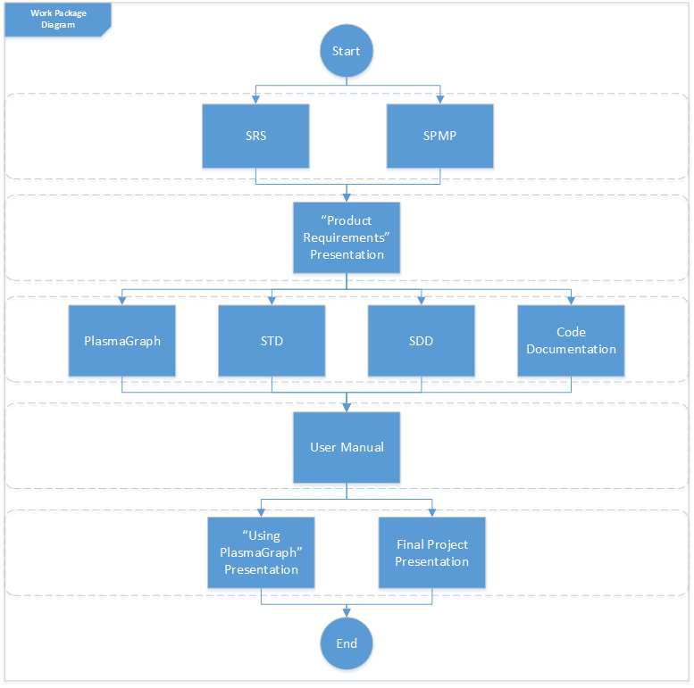

Figure : "PlasmaGraph Program" Work Package Dependency Diagram

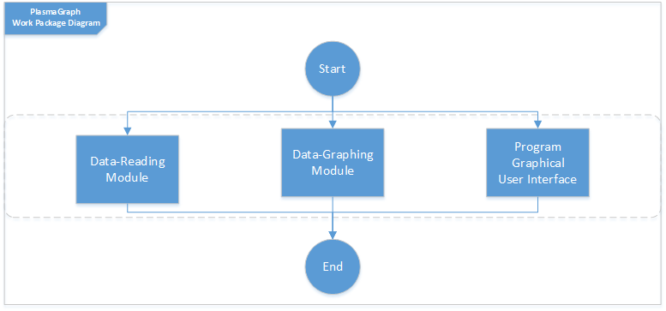

As presented in these diagrams, each set of concurrent work packages is presented in a different row. In order to continue to the next row, each work package in the current row must pass the initial draft process detailed in Section 2.1 of this document.

## 5.3. Resource Requirements

The following resources will be needed for the completion of this project (See Section 5.4 for the cost of each of these resources):

1. Hardware and Software

1. Hardware

The project team will utilize two laptop and one desktop computers, as well as the desktops in the PUPR Computer Lab located in P-103 to complete all work packages as detailed in section 5.1 of this document.

2. Software

The project group will use a number of software programs in order to complete the work packages. The software, along with the category of software each falls into, is listed in Section 4.1.

1. Temporary and Permanent Locations

1. Temporary Locations

The following locations will be used:

* PUPR Campus - Library - Study Rooms: Project team meetings.
* PUPR Campus – Classroom P-103: Project team meetings and client meetings.
* PUPR Campus - Classrooms L-310, EPL-2: Meetings with Advisor.
* PUPR Campus - Plasma Laboratory: Meetings with Client.

2. Permanent Locations

No permanent locations will be needed for the purposes of completing this project.

1. Human Resources

The Project and Design Managers will work on all work packages except the SRS, STD, and SPMP packages. The Project Manager will manage the GitHub file repository. Presentations will be given by both members. The team will rely on university faculty to review their SRS, SDD, STD, and SPMP documentation.

1. Meeting Logs

Meeting Logs will be maintained by the Project Manager and will be provided in the final package along with the rest of the items.

1. Time

The time necessary for the completion of this project, as well as for each individual Work Package, is detailed in Appendix A: Project Gantt Chart

The following table details all the Software, Hardware, and Human Resources used in each Project Deliverable.

Table : Resources Used for Project Deliverables

| Project Deliverable | Software Resources | Hardware Resources | Human  Resources |
| --- | --- | --- | --- |
| Software Requirement Specification (SRS) | Document, Diagramming, Image-Manipulation | All computers. | Design Manager. |
| Software Design Description (SDD) | Document, Diagramming, Image-Manipulation | All computers. | Project and Design Manager. |
| Software Test Document (STD)  and Test Result Report(s) | Document, Image-Manipulation | All computers. | Design Manager. |
| Software Project Management Plan (SPMP) | Document, Scheduling, Diagramming, Image-Manipulation | All computers. | Project Manager. |
| Project Weekly Reports | Document, Image-Manipulation | All computers. | Project Manager. |
| Data Reading Module | Programming / IDEs, Internet | All computers. | Project and Design Manager. |
| Data Graphing Module | Programming / IDEs, Internet | All computers. | Project and Design Manager. |
| Program Graphical User Interface | Programming / IDEs, Internet | All computers. | Project Manager. |
| Code Documentation (Javadocs) | Document, Programming / IDEs | All computers. | Project and Design Manager. |
| User Manual and Installation Guide | Document, Programming / IDEs | All computers. | Design Manager. |
| “Product Requirements” Presentation | Document Software, Presentation Software | All computers. | Project and Design Manager. |
| “Using PlasmaGraph” Presentation | Document, Presentation | All computers. | Project and Design Manager. |
| Final Project Presentation | Document, Presentation | All computers. | Project and Design Manager. |
| Project Poster | Document, Image-Manipulation | All computers. | Project and Design Manager. |

## 5.4. Budget and Resource Allocation

The resources required (and their budget allocated) are as follows:

Table : Project Resources and Budget

| **Resource** | **Amount** | **Resource Type** | **Resource Sub-Type** | **Projected Cost** | **Actual Cost** | **Notes** |
| --- | --- | --- | --- | --- | --- | --- |
| Laptop | 1 | Hardware | N/A | $399.99 | $399.99 | Team members Gerardo Navas' personal computer. |
| Desktop | 1 | Hardware | N/A | $700.00 | $700.00 | Team member Daniel Quintini's personal computer. |
| Desktop | 1 | Hardware | N/A | $856.00 | $856.00 | Team members Gerardo Navas' personal computer. |
| OpenOffice Calc | 1 | Software | Document | $0.00 | $0.00 | Free Software. |
| OpenOffice Draw | 1 | Software | Diagramming | $0.00 | $0.00 | Free Software. |
| OpenOffice Impress | 1 | Software | Presentation | $0.00 | $0.00 | Free Software. |
| Microsoft Word 2013 | 1 | Software | Document | $109.99 | $0.00 | Free for PUPR students via university computers. |
| Microsoft PowerPoint 2013 | 1 | Software | Presentation | $109.99 | $0.00 | Free for PUPR students via university computers. |
| Microsoft Visio Professional 2013 | 2 | Software | Diagramming | $1,179.98 | $0.00 | Free for PUPR students via Microsoft Dreamspark. |
| Microsoft Project 2013 | 1 | Software | Scheduling | $589.99 | $0.00 | Free for PUPR students via Microsoft Dreamspark. |
| Dia | 2 | Software | Diagramming | $0.00 | $0.00 | Free Software. |
| Sublime Text 3 | 2 | Software | Document | $0.00 | $0.00 | Free Software. |
| Eclipse | 2 | Software | Programming / IDE | $0.00 | $0.00 | Free Software. |
| NetBeans IDE | 2 | Software | Programming / IDE | $0.00 | $0.00 | Free Software. |
| GIMP | 1 | Software | Image Manipulation | $0.00 | $0.00 | Free Software. |
| Paint.NET | 2 | Software | Image Manipulation | $0.00 | $0.00 | Free Software. |
| MSPaint | 2 | Software | Image Manipulation | $0.00 | $0.00 | Free Software. |
| GitHub – Free Project Repository | 1 | Software | Version Control / VCS | $0.00 | $0.00 | Free Software. |
| GitHub – Windows Program | 2 | Software | Version Control / VCS | $0.00 | $0.00 | Free Software. |
| Mozilla Firefox | 2 | Software | Research | $0.00 | $0.00 | Free Software. |
| Google Chrome | 2 | Software | Research | $0.00 | $0.00 | Free Software. |
| PUPR Library Study Rooms | 1 | Locations | Temporary | $0.00 | $0.00 | Free for PUPR students. |
| PUPR Rooms  P-103,  L-310, EPL-2 | 1 | Locations | Temporary | $0.00 | $0.00 | Free for PUPR students. |
| PUPR Plasma Laboratory | 1 | Locations | Temporary | $0.00 | $0.00 | Free for PUPR students. |
| Project Manager – Wage | 1 | Personnel | Team Member | $37,000.00 | $37,000.00 | http://www.payscale.com median wage multiplied by project duration. |
| Design Manager – Wage | 1 | Personnel | Team Member | $37,000.00 | $37,000.00 | http://www.payscale.com median wage multiplied by project duration. |
| Total Costs |  |  |  | $77,945.94 | $75,955.99 |  |

## 5.5. Schedule

The project’s schedule is as follows:

Figure : Project Phase Schedule - Phase A



Figure : Project Phase Schedule - Phase B

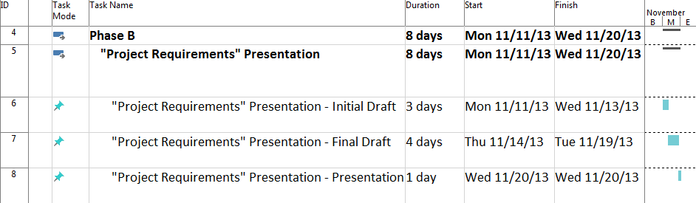

Figure : Project Phase Schedule - Phase C

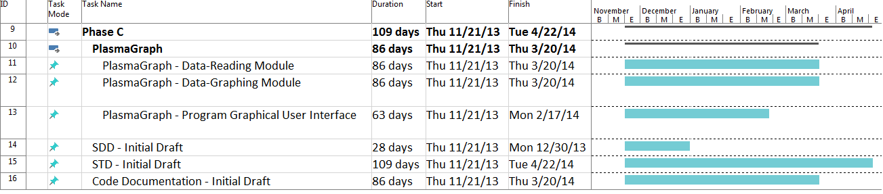

Figure : Project Phase Schedule - Phase D

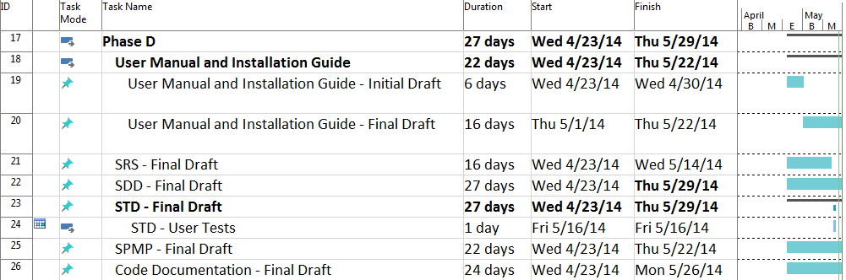

Figure : Project Phase Schedule - Phase E

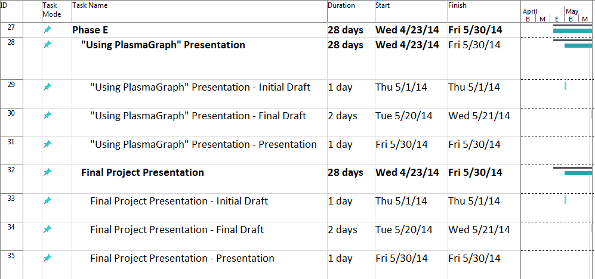

# Appendix

## Appendix A: Advisor Meeting Notes

